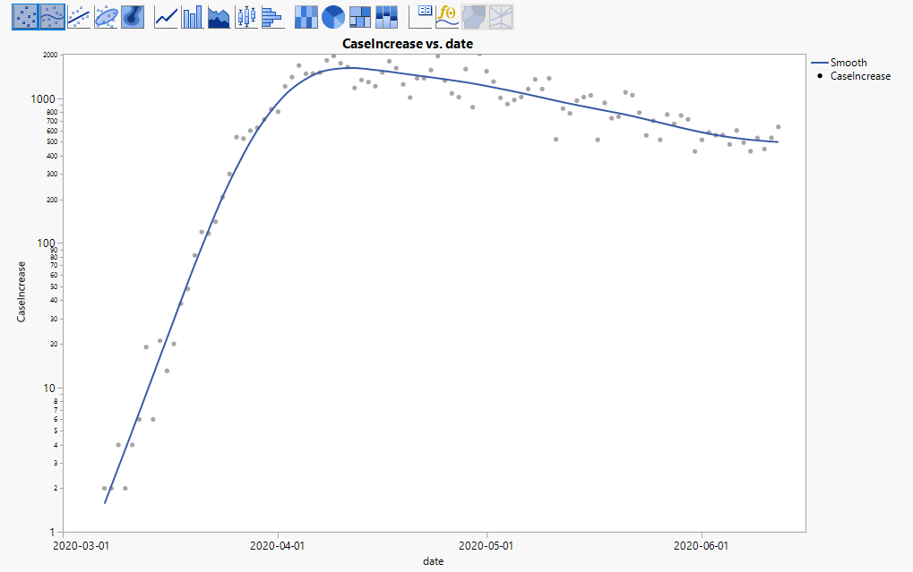

Initial Scatter plot of Log(CaseIncrease) vs Date

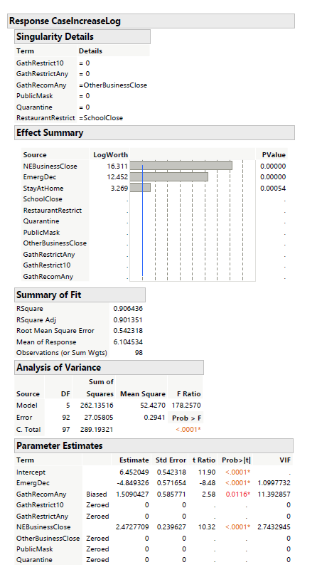

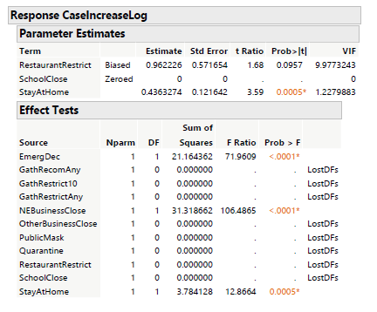

First regression run. Revealing features that were zeroed out, biased, insignificant, and correlated with eachother.

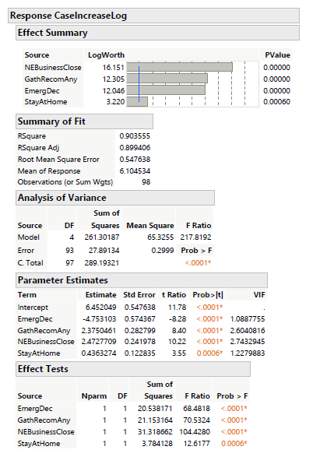

After running multiple regressions and eliminating features, this is the final regression model we came up with. Finding that EmergDec (Emergency Declaration), GathRecomAny (Gathering Recommendation Any Amount of People), NEBusinessClose (Non-Essential Business Close), and StayAtHome.

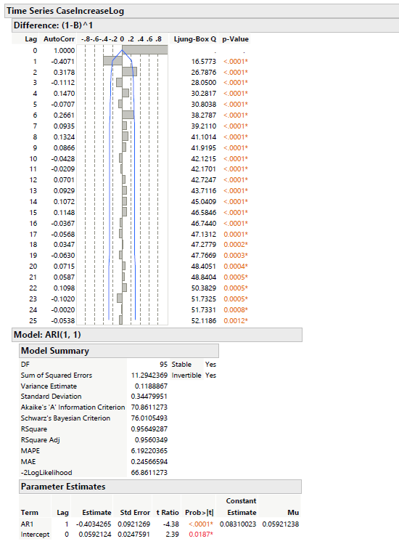

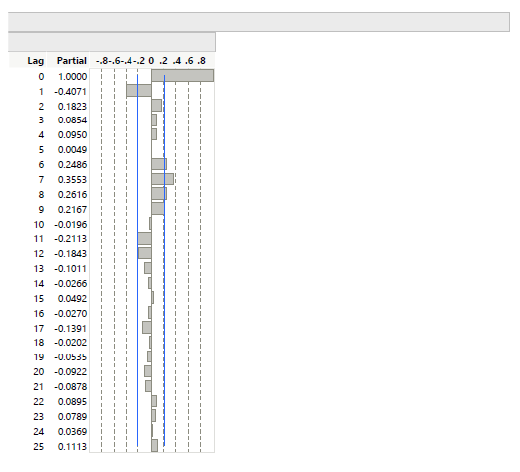

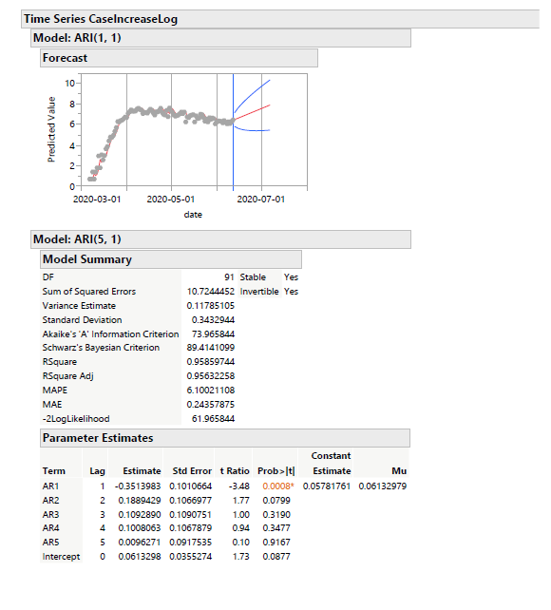

Running time series.

Arima

Nonseasonal differencing order: 1

Differencing order: 1

Autoregression: 1

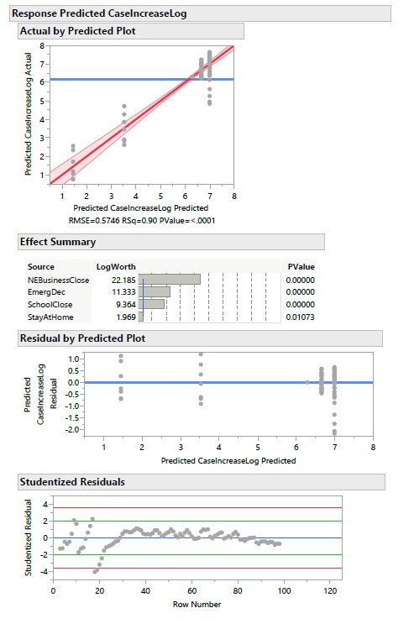

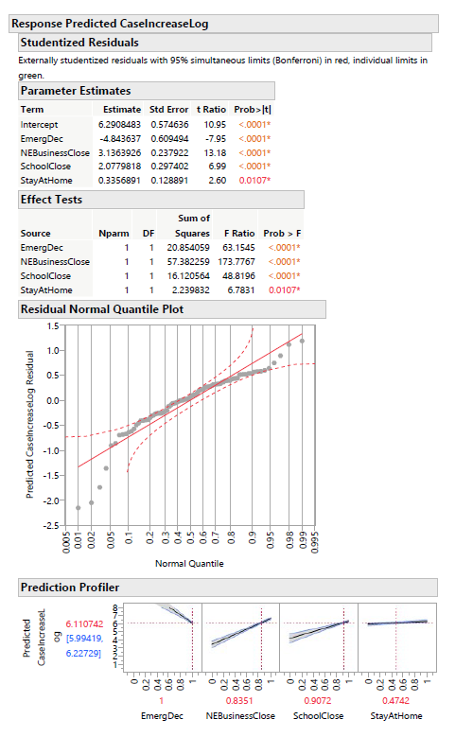

Final Arima Result.